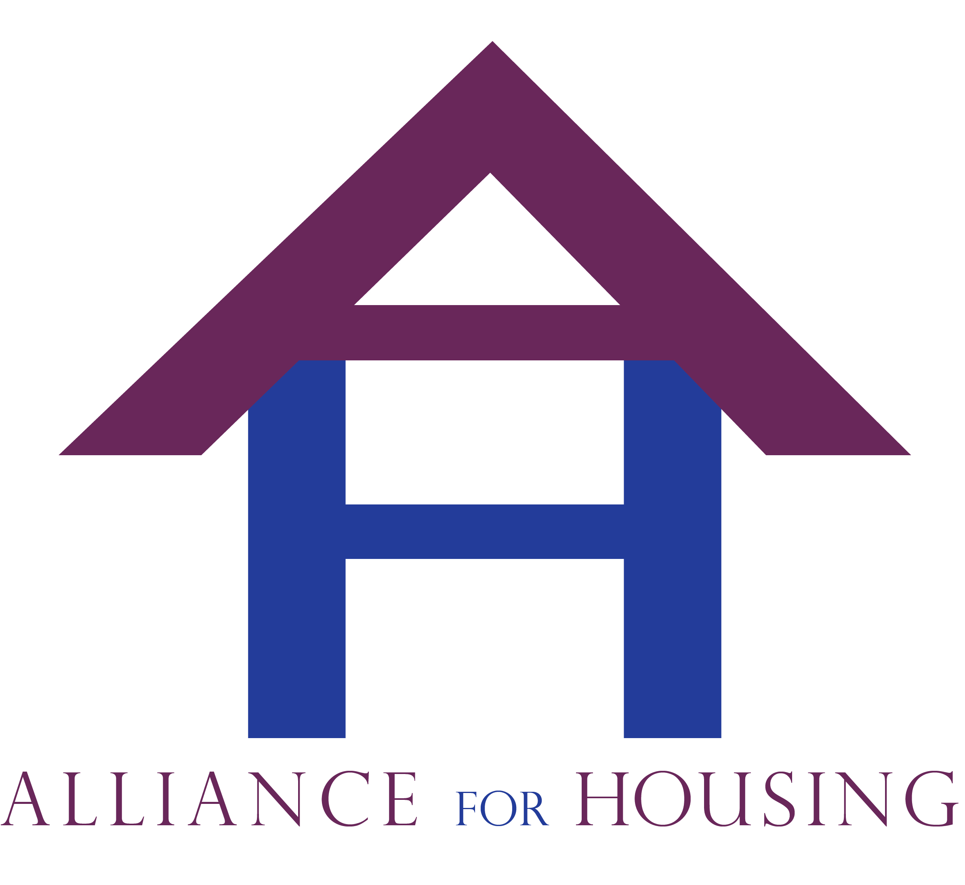
Alliance for Housing
Bi-monthly General Membership Meeting; Tuesday, September 16, 2014
Meeting Minutes - Respectfully submitted by Daniel Kelly
Attendance: Leah Mccall (Alliance for Housing), Ecole Brooks (OCHD-OSAS), Marc Craig (CHN), Jim Perlaki (Common Ground), Ernestine Mcrae (HAVEN), Rachel Densmore (OCCMHA), Debra Hendren (CHN), Jill Shoemaker (CHN), Bradley Jones (GCH), Michelle Atwell (Grace Centers of Hope), Daniel Kelly (SOS), Jenny Poma (SOS), Michelle Edwards (MSHDA), Garth Wooten (OC VET SVCS), Ebonne Clark (Easter Seals), Deborah Busch (Busch Housing), Heather Zimmerman (MDOC), Dawn Pischel (CHN), Kathy Williams (OCCHI), Raymond Hagerman (Oakland Schools Wrap Around), Jamie Christofel (CHN), Melody Farr (Pontiac Timebank), Ursula Bolton (Livelove), Kim Hodge (Pontiac SUN timebank), Sharman Davenport (Lighthouse), Julie Nagle (Humble Design), Treger Strasberg (Humble Design), Denise Goshton (MHC)
Introductions
Meeting was called to order at 1:35pm.
Leah Mccall called for introductions.
Leah asked if there were any additions to the agenda. There were no additions. The agenda for the general membership meeting was approved. Kathy Williams motioned and Ernestine Mcrae seconded approving the minutes from the July Alliance General Membership Meeting.
Announcements
Dan Kelly noted that South Oakland Shelter had received the Oakland County Emergency Solutions Grant. He described the program to the membership. He noted that the goal of the program is to assist households at-risk or homeless with maintaining or re-gaining housing stability. He stated the program assists with short term rental assistance, security deposits, utility assistance, and moving costs. He passed out flyers and a screening tool, noting that HMIS providers can refer people right through HMIS. He stated that non-HMIS providers can use the simple screening tool and return it via email or fax. (numbers listed on the tool) He noted that those with any questions can contact him at 248-809-3773 or via email at dkelly@oaklandshelter.org for more information. He noted he would send the screening tool and flyers over email to the listserv.
Kathy Williams noted that Oakland County Home Improvement has ramped up their Home Improvement Loan Program. She asked that providers with clients interested who live in Oakland County to refer them to the office.
Jenny Poma noted that the National Association for the Education of Homeless Children and Youth is hosting a Oakland County Youth Homelessness Taskforce Meeting on September 18, 2014 from 9:30am-11:00am at South Oakland Shelter, 18505 W. 12 Mile Rd., Lathrup Village, MI 48076. She invited membership to participate and passed out a flyer.
Presentation
Treger Strausburg presented. She described that the program helps people escaping homelessness with “an extreme makeover” on their home. She described the process to creating this non-profit, stating that she was volunteering in 2009 at Forgotten Harvest and helped a homeless mother with furnishing her home. She then started working with other non-profits in the community with furnishing people’s new homes including South Oakland Shelter and HAVEN. She noted that the non-profit then started from their; they are now receiving over one million dollars in furniture, and have a large warehouse in Pontiac. They work with social workers from local non-profits via a tool on their website at humbledesign.org. There is no more red tape other than submitting this form. They then meet with the families and learn their wants and needs for housing. After the meeting, they put together all the furniture this family needs and then deliveries it to them and set it up. After furniture is delivered, home designers put together the home. There is a waiting list for clients to access this service. Humble Design requests a $30 donation to pick-up furniture donations as well. Treger stated they deal with 85% single mothers.
Treger stated their main goal is that those served stay in the home permanently. She also would like the families participating in the community at period intervals of 6 weeks, 6 months and one year after assistance. She stated that for more information, please go to their website at humbledesign.org.
She would like to discuss collaborating with any of the Alliance for Housing service providers. She stated they would like to collaborate on grants and other ways to work together.
Michelle Atwell asked if Humble Design was expanding their mission to work with people to help them sustain housing. Treger stated she is looking to work with non-profits to aid in the effort to help households maintain housing.
Wilma Abney presented on the Community Ventures program through the Center for Working Families. The Community Ventures program focuses on: employment, financial literacy, connecting with new financial supports, and stabilizing them. She stated the Center for Working Families and the Community Ventures program are connected. She stated the Center for Working Families works with clients on budgeting and other financial literacy aspects as well. She noted that the system is set-up to work with households one on one. She stated that the Center for Working Families is a federally funded program; she stated Lighthouse has been funded for five years. She stated they are best able to help clients that are stabilized, in a home, and best ready to take the steps toward self-sufficiency. The three components of the Center for Working families focuses on: financial literacy, developing a budget, and helping with income supports. She stated they have a computer room available as well. She passed out flyers and stated she would send them out on the listserv.
Wilma also presented on a State wide initiative in employment. She stated that Community Ventures is working on this initiative. She stated the goal of this initiative is to link those who are structurally unemployed with participating companies to link them to employment. She stated the program works to keep those served employed for a full year by following up with them and assisting them with maintaining employment. She stated this is extremely challenging; they work on helping clients gain employment skills. She stated the program has a high success rate of those served maintain ongoing employment.
Garth Wootten presented from Oakland County Veteran Services. He noted he’s the Division Manager for the Oakland County Veteran Services organization, part of Oakland County government. He noted that recently the VA hosted a homeless summit for veterans and challenged those participating at this summit in Detroit to end Veteran homelessness within 100 days. He noted that HMIS noted there are 146 homeless Veterans and 71 chronically homeless Veterans in Oakland County. He stated the goals they came up with were to service 200 Veterans in the first 30 days and house 111 veteran families in the next 100 days. He stated there are several programs available to assist Veterans including: the Housing and Urban Development (HUD) Veterans Assistance Supportive Housing (VASH) program, Supportive Services for Veteran Families (SSVF) program, and many others including employment preferences. He stated one of the challenges in achieving their goal is to successfully identify Veterans as they don’t necessarily want to identify as homeless or identify as Veterans because of previous poor treatment, physical or mental disability, or other reasons. He stated that some Veterans may not qualify for Veterans services due to discharge type, length of time served (too low), or having too high of income. He stated that his goal is to help Veterans connect with benefits. Long term, their goal is to get more Veteran specific permanent supportive housing in Oakland County. He stated they would also like to have a Veterans stand down in Oakland County in the future. He stated they’re having the first Veterans homelessness taskforce meeting on October 6th, at 10:00am in Building 26E in the 1200 North Telegraph Oakland County Complex in Waterford, MI. He stated anyone who needs services can reach out to Oakland County Veteran Services in Pontiac – 248-858-0785.
Committee and Workgroup Reports
Board Report
Marc Craig reported. He noted that the Board has decided to hire accounting help for the Alliance. He stated they are institutionalizing accounting procedures and are working on getting set-up in the Housing and Urban Development (HUD) funding system (LOCCS). He stated they are actively working on obtaining new board members including Deb Brinson of Oakland County Integrated Health Network.
Operations
Kathy Williams presented. She noted they would love to have additional members. She stated the committee’s job is to work on the business end of the Alliance. She stated the group works on deciding if the Alliance should join new grant initiatives as well. She stated the group sets agenda items for the general membership as well. She stated the committee has gotten the meeting notices for committees up on the Alliance website at oaklandhomeless.org.

Systems Coordination & Implementation
Ernestine Mccrae reported. She noted that the Affordable Housing Committee is looking to educate the community about what we do and stewarding developers in the community.
She stated that only two people have volunteered to get involved in the prevention workgroup. She stated they will need more people to get involved.
Elizabeth Kelly reported on the ID taskforce. She noted that the group is still working on helping change policies and procedures to obtain state identification. She stated that they are working directly with the legislator who works with the Secretary of State on creating rules and policies related to state ID obtainment. She stated they are working with the special exemptions unit at the state to streamline ID obtainment procedures utilizing the Homeless Management Information System (HMIS) and other systems. They are working on a pilot program to do this. Next meeting is on October 20th, at 2:00pm.
Deb Hendren presented on the PSH partnership meeting. She noted that the committee met today and they hope to be up and running October 1st, 2014. She stated that they have created a new intake procedure in HMIS to aid in this process.
Finance & Audit
Jim Perlaki presented. He noted that the work on the financial policies and procedures manual has been completed. He noted there is a financial document that will be presented to the Board and general membership on an ongoing basis. He noted our fiscal year is October 1st – September 30th. He explained that on the form the money transfer from Lighthouse as the previous fiduciary occurred on June 1st, 2014. He noted that membership dues were collected earlier this year in the amount of $1,000. He noted that the cost of Patrice Martin, contractor utilized to aid with COC processes last year, was also noted on the financial documents. He noted that the balance currently is approximately $10,000. He noted there are two checking accounts; one for the Alliance as an organization, and one to keep track of HUD grant activities.
Advocacy & Public Awareness
Leah Mccall presented. She noted the next meeting for the Public Awareness committee is Tuesday, September 30 at 3:00pm at the Furniture Bank of Southeastern Michigan, 333 N. Perry St., Pontiac MI. She stated the committee is to create public service announcements and press releases, including a video public service announcement commercial for the upcoming Community Resource Day on Wednesday, November 19, 2014.
Project Monitoring and Performance Outcomes (HMIS)
Leah Mccall reported. She stated the Outcomes committee is working on creating a community performance outcomes plan and has outlined goals in a one page document. Leah Mccall noted that all the site visits for those receiving HUD funding have been completed. She noted that in general the visits went very well and there were no major issues; she noted that each program had unique approaches to grant administration that should help the COC programs improve in general in the County.
Jill discussed HMIS changes. She noted that the system is upgraded and there will be changes in how data is captured in the system. She stated the COC is running high quality data with either an A- or A report card when running HMIS data quality reports. She stated the Annual Homeless Assessment Report (AHAR) reporting will begin shortly. She stated the VI and full Service Prioritization and Decision Assistance Tool (SPDAT) are integrated into HMIS currently. Kevin Bogg asked how end users are going to be trained. Jill noted that end users will be trained through agency administrators and through podcasts.
Region 10 Report
Leah Mccall presented. She noted she attended the meeting and that the Salvation Army presented noting that funded agencies will not be able to increase their funding as they have in the past.
HARA Single Point of Entry Report/Update
Debra Hendren reported. She noted that there is an upcoming Landlord Breakfast at the Clinton Macomb Library on November 13th, 2014. She noted that the event will include networking with landlords.
She noted that the MSDHA ESG 2014 fiscal year funding will be released very soon to aid homeless and at-risk families.
Jamie Christofel noted that a large 170 person Homeless Preference Voucher pull in Oakland and Macomb, Friday, September 26th at Community Housing Network, 570 Kirts Blvd. from 9 to 11am and 1:00 – 3:00pm. She also noted that the Moving Up Voucher program is moving people from Permanent Supportive Housing (PSH) to this new program on an ongoing basis.
Old Business
Health Care Collaborative Update
Gloria Lutey presented. She noted that meetings occur at 2100 North Telegraph Building, 34 E, Pontiac MI 48341. The meetings are from 2:00pm – 4:00pm. They are February 19, 2015; April 16, 2015; June 18, 205; August 20, 2015; October 15, 2015; December 17, 2015.
Community Economic Development Association of Michigan – Alliance for Housing is now a member organization

New Business
SPDAT Train the Trainer
Dan Kelly reported. He noted that he and Jessie Korte attended the SPDAT Train the Trainer program on Wednesday, September 10, 2014. They are currently working on creating a training process for the SPDAT in Oakland County.
Community Resource Day
Dan Kelly reported. He asked for anyone interested to join the planning committee and that they are meeting on September 17 at 11:00am at 123 Wesson St., Pontiac, MI 48341. He passed out flyers for the event and noted he would send an updated flyer the next week for distribution. He also noted that there will be a large banner and lawn signs for vendors/agencies signed up. The event is Wednesday, November 19th, 10:00am – 3:00pm. He asked that any additional vendors/organizations please sign up for the event and passed around registration forms. He also noted that there will be video and standard format Public Service Announcements and press releases are going out soon for the event. In addition, he asked that any agencies that receive calls for service utilize a call script to inform callers of the event.
Operation Finding Home
Michelle Edwards reported. She noted that MSHDA has a pilot program to aid homeless households with getting out of encampments and into permanent housing. She noted they completed a pilot program in Grand Rapids and it was very successful; the program worked to connect these households with housing and wrap-around services. She noted that she would like Oakland County to apply for the grant as there were a few encampments in the County. Michelle Edwards noted that MSHDA’s goal is to have this be a positive impact on the community.
Street Count
Leah Mccall reported and noted that they are looking team leaders for the street count in the last week of January 2015. She asked anyone who was interested in participating to contact her at lmccall-alliance@oaklandhomeless.org
Zero 2016 Campaign
Leah Mccall presented. She noted that this program is a way for our community to target Veteran and Chronic homelessness and work streamline resources and services as a community. She noted it is still vague around the goal of the program. Leah Mccall noted that HUD is strongly encouraging our community to participate. Leah noted that she would like the COC to be involved.
Adjournment
The meeting was adjourned at 3:30pm
The next meeting will be Tuesday, November 18th at the Oakland Schools Building, 211 Pontiac Lake Rd.

