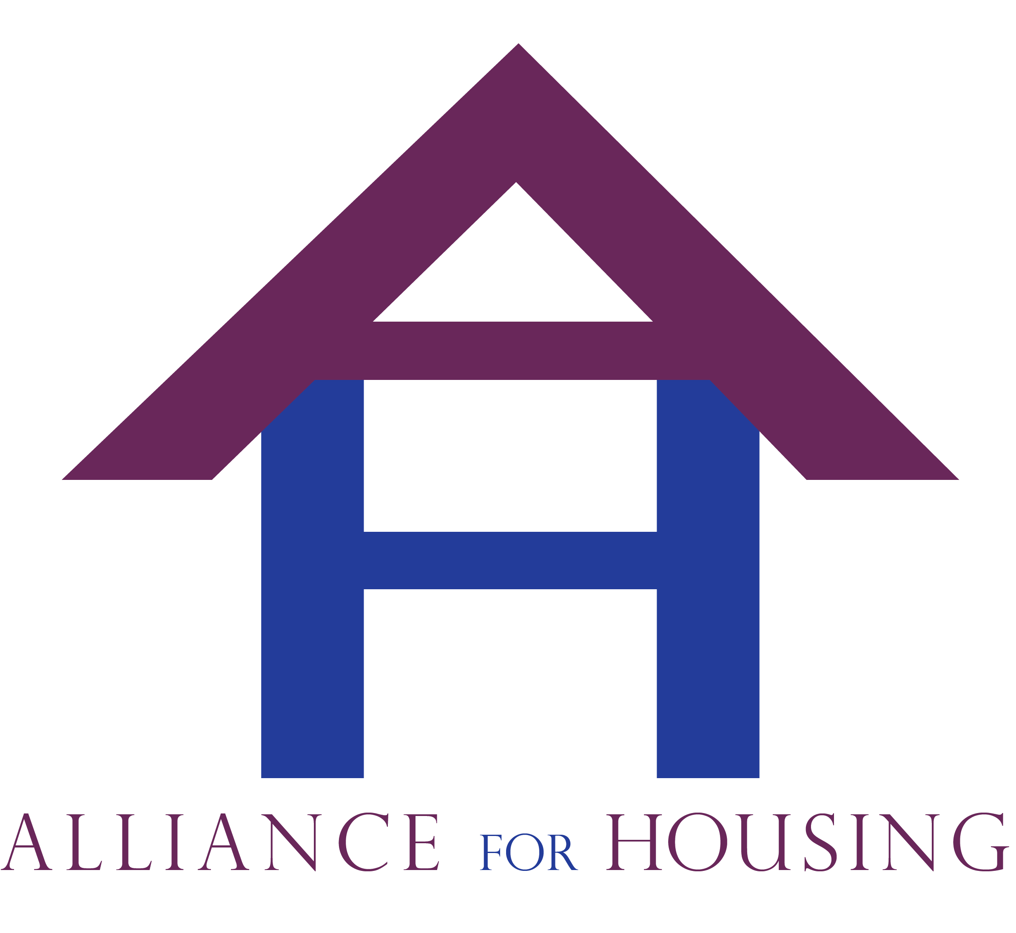
Alliance for Housing
Bi-monthly General Membership Meeting; Tuesday, July 8, 2014
Meeting Minutes - Respectfully submitted by Daniel Kelly
Attendance: Leah Mccall (Alliance), Karla Chambers (Springhill Housing), Jill Shoemaker (HMIS), Melanie Dovitz (JFS), Dan Kelly (SOS), Kevin Bogg (TTI), Jamie Christofel (CHN), Elizabeth Kelly (HOPE), Ernestine Mccrae (HAVEN), Deborah Busch (MSHDA), Jenny Poma (SOS), Jim Perlaki (Common Ground), Marc Craig (CHN), Anne Dyet (New Passages/HOPE Network), Gloria Lutey (OCHD), Bev Weir (OCHD), Johnna Renae (TTI), Zachary Dieck (TTI), Michelle Atwell (Grace Centers of Hope), Debra Hendren (CHN), Dawn Pischel (CHN) Sara Orris (Oakland Schools)
Introductions
Meeting was called to order at 1:38pm.
Marc called for introductions.
Marc asked if there were any additions to the agenda. There were no additions. The agenda for the general membership meeting was approved. Jim Perlaki motioned and Kevin Bogg seconded approving the minutes from the May 12, 2014 annual Alliance retreat.
Announcements
Marc announced Leah McCall as the Alliance’s new Executive Director.
Jamie Christofel from CHN announced there will be another wait list pull in the near future for the Homeless Preference Voucher (HPV) Program. She mentioned there another wait list pull. She also noted that an HPV briefing meeting is scheduled for July 18th.
Presentation
Elizabeth Kelly presented. She stated HOPE has purchased new beds to better equip the shelter. She said she noticed an uptick in shelter calls for women. Elizabeth noted that their shelter is a low barrier shelter that leverages relationships with outside agencies to assist clients served. Elizabeth noted that the shelter is now open year round. She noted there is a clinic on site at the shelter to assist in meeting the health care needs of clients. Elizabeth noted they are in the process of opening a specialty recuperative center to aid those who are homeless exiting hospitals. She noted there are 64 of these centers in operation around the country. She stated this program works to connect clients with housing and community-based services on an intensive basis. She stated that nationally about 90% of those discharged from recuperative centers exit into housing. She stated they have talked to the CEOs of 2 local hospitals to get them on board with this program; they plan on talking to two more hospitals soon. She stated the program targets people who are frequent users of services at hospitals, especially those who are utilizing emergency services frequently. She stated she has a location for the center identified in Royal Oak. She noted overall there is a humane and cost savings value to this service.
Elizabeth also discussed obtaining a Birth Certificates for those experiencing homelessness. She noted that the Oakland County Board of Commission has passed a fee waiver process for clients to obtain a free Birth Certificate. She stated agencies would need to contact the Oakland County Clerk’s office to facilitate this process. She stated this is a new process so there may be bugs still in the process. She stated in Wayne County an individual can obtain a half-priced Birth Certificate as well. She stated she is working on obtaining waivers for certain provisions of obtaining Michigan State Identification. She stated she and Debra Hendren attending a meeting in Lansing with the Secretary of State’s office and were told the rules were applied through state statue. She said the Secretary of State is working on the ID taskforce for the Alliance to better help homeless households. She stated the Secretary of State informed her that they are willing to work on how to identify fee waivers when an individual has no income. She stated that if anyone was interesting in getting involved further to please email her at ekelly@hopewarmingpontiac.org. She stated the next Michigan ID taskforce meeting is July 21st at the Oakland County Health Division
Jim Perlaki asked the question about whether there is concern that now HOPE has moved to year-round services that it may become a housing unit for individuals – i.e. they will seek long term housing at the shelter. Elizabeth stated their average length of stay is only 39 days and that they only have perhaps 5 individuals who may fit that criterion currently. She stated her Board of Directors is wary of setting limits on providing shelter due to the low barrier philosophy of the agency.
Deb Brinson presented on the Oakland Integrated Health Care Network (OIHN). She is currently the CEO of the network. She stated that OIHN is looking to become a full Federally Qualified Health Center (FQHC) site. She stated becoming this entity is very important as it allows OIHN to get an enhanced billing rate for Medicaid, FQHC’s receive liability coverage to help the organization save, and there are also opportunities for funding that only an FQHC can obtain. She stated OIHN is serving over 9000 people a year with over 30,000 services per year. She stated there are dental services in place as well at multiple sites. She stated there may be opportunities to receive funding to assist those experiencing homelessness; including for a mobile health unit. She stated they are getting ready to hire a new nurse practitioner.
Committee and Workgroup Reports
Board Report
Marc Craig reported. He noted the Board worked substantially recruiting a new Executive Director in Leah Mccall. He stated Leah’s role will be to move the Alliance toward becoming a United Funding Agency.
Operations
Leah Mccall presented. She noted that at the last meeting the committee created the agenda for the current general membership meeting. She noted the group also focused on the Tier 2 process with HUD COC program.
Systems Coordination & Implementation
Ernestine reported. She noted that the chronic homelessness forum would like to create two new committees; the affordable housing committee and prevention committee. Deb Hendren reported on the work of the Coordinated Interagency Service Team Committee (CIST). She stated the committee is working on implementing the new Service Prioritization and Decision Access Tool (SPDAT) with service providers. She stated the tool will allow providers to link services based those most in need of the services. She stated there are upcoming webinars and training programs for utilizing this tool. She stated the webinars are being help July 11 and August 8th at 1:00pm at CHN. Please contact her for more information. Kevin Bogg and Jim Perlaki noted they both liked the tool when they went to the training. Jill Shoemaker reported that HMIS has been updated to include the SPDAT assessment tools. Jill stated that there are podcasts to be trained on these tools on the Michigan Campaign Against Homelessness (MCAH) website. She stated that all using this tool need to complete this podcast in addition to the quiz that is with it.
Debra Hendren reported on a new Moving Up Voucher. She noted that this voucher is for those in Permanent Supportive Housing (PSH) who no longer need services however still need a housing subsidy. She stated there are currently 19 people they are going to put on the list; there are 50 current slots available. She stated the program is voluntary for households. She stated there are certain threshold requirements including income and public housing requirements. Deb noted the program is using an assessment tool to screen people who are ready for “moving-up”. She noted that there are more stringent bedroom requirements for the MSHDA vouchers as opposed to PSH requirements.
Ernestine noted the next Chronic homeless forum is September 17, 2014, 9:00am – 10:30am at the Oakland County Executive Building, Waterford, MI.
Finance & Audit
Jim Perlaki presented. He noted that Lighthouse has been the fiduciary for COC funds for over 15 years. He noted that the Alliance is taking on it’s own financial obligations internally moving forward. Jim noted that the COC has opened two bank accounts; one to do drawdowns for the HUD Alliance COC program grant and one for general operations of the Alliance. Jim stated he is waiting for checks in order to start general business for the Alliance financially. He did not have a financial report the for current meeting. He stated they are working on creating financial control policies.
Advocacy & Public Awareness
Dan Kelly presented. He noted the next meeting for the Public Awareness committee is Tuesday, July 15 at 3:00pm at South Oakland Shelter, 18505 W. 12 Mile Rd., Lathrup Village, MI 48076. He stated the committee is going to work with the new Executive Director, Leah Mccall, to ensure the website is meeting the Alliance’s needs in addition to creating external communication policies.
Project Monitoring and Performance Outcomes (HMIS)
Leah Mccall reported. She stated the Alliance is coordinating project monitoring visits for the next few months. Jill stated they will be utilizing the same HMIS piece as last year for the monitoring visits. She stated the committee is still seeking people to join. Their next meeting is scheduled for July 14 at 10:00am Community Housing Network. Jill asked anyone interested in joining the event. Jill also noted the annual report is completed and uploaded to the Alliance website. She stated there have been data discrepancies found for identifying whether people are chronically homeless. She stated that HUD has put out new HMIS data standards. She stated there may be changes needed with agencies in regards to HMIS workflows. Jill stated there will be a breakout session at the homeless summit on the Advanced Reporting Tool (ART); she encouraged any agency administrators for HMIS to attend. She stated the group is looking into beginning to utilize the eligibility point tool, a new HMIS tool.
Region 8 Report
Jim Perlaki presented. He noted the next meeting is Thursday, July 10th. He noted the Region is now 10 for Oakland County. He stated the last meeting was very brief where there was discussion about whether or not the region meetings are helpful.
HARA Single Point of Entry Report/Update
Debra Hendren reported. She noted that the ESG rapid re-housing program still has money through CHN. She noted that the program still has $4,000 still left. She noted that the Homeless Preference Voucher program is going to recertify homeless status every 120 days for households on the waitlist. She stated that the voucher process will need to be presented at each COC meeting.
Old Business
HUD Continuum of Care Award Announcement
Leah noted that there were three programs in Tier 2 and two were funded. She noted that the Lighthouse supportive services only grant for approximately $70,000 was defunded. She noted that the two Tier 2 programs that were funded were Lighthouse permanent supportive housing and CHN’s rapid re-housing grant.
New Business
MSHDA ESG
Marc Craig reported. He noted that there are a few significant changes with the MSHDA ESG grant this year: 1) the Match requirement is eliminated, 2) Domestic Violence providers will be obtaining ESG funding from the Department of Human Services rather than MSHDA ESG, 3) The Homeless Preference Voucher (HPV) process will change in terms of how households are certified and qualify (must be re-certified homeless every 120 days), and 4) the HARA must have dedicated staff.
Community Resource Day
Dan Kelly reported. He noted that Community Resource Day is scheduled for Wednesday, November 19, 2014 from 10-3pm at Trinity Church, 123 Wesson St., Pontiac MI 48341. He passed out save the date flyers and noted the group is meeting July 15, 2014 at 2:00pm at South Oakland Shelter, 18505 W. 12 Mile Rd., Lathrup Village, MI 48076. He noted that the committee’s goal is to get 215 participants at the event and their current strategy is to prioritize getting agencies and vendors on board early to aid in marketing and outreach strategies.
Retreat Survey
Dan Kelly reported. He passed out survey results and noted that the Alliance retreat was very successful. He noted that respondents would like more participation from a greater array of service providers.
Homeless Health Care Collaboration
Gloria Lutey presented. She noted that the group has been working on the recuperative care center efforts. Jim Perlaki noted that the committee has won a national award in the last year for community collaboration in Health Care services.
Prevention Work Group Committee
Jamie Christofel presented. Shen noted that there is an eviction diversion program currently in the process of being created in Pontiac. She stated they developed a proposal to be submitted to the Alliance Board in August 2014. She stated there is a prevention work group committee to be created as a result of this work. Marc Craig stated the committee should provide further direction to the eviction diversion program as well as help address other prevention needs. A sign-up sheet for the committee was passed around.
Affordable Housing Development Committee
Ernestine reported. She noted that at the Chronic homeless forum; a need for a new committee, an affordable housing committee was noted. A sign-up sheet for this committee was passed around. Marc Craig noted that there is a need for this committee to address affordable housing needs in the community. He also noted that for MSHDA funding, they are now requiring developers to speak with COCs before obtaining funding.
CEDAM – motion to join
Marc noted that CEDAM is an organization that assists communities with meeting their community and economic needs. The membership is $150/year. Leah asked if the membership could vote on the Alliance joining this committee. Leah Mccall motioned, Ernestine Mcrae seconded the motion. The motion carried unanimously. Marc Craig obtained from the vote.
Alliance non-competing for funding with partners discussion
The group discussed what this policy in the Alliance bylaws means. Jim Perlaki noted that the Alliance should be able to collaborate with service providers on grants; he stated the Alliance should not be conducting direct client services.
Board member attendance bi-law updates
Marc Craig reported. He noted that there is minimal representation from some “charter” organizations on the Alliance Board. Marc stated he would like to change the Alliance by-laws to change the standards for board member participation. The goal is to make these goals more stringent so there is more participation with the Board members.
Adjournment
The meeting was adjourned at 3:54.

